EE-2003: Computer Organization & Assembly Language
Date: 4th April, 2024
Course Instructor(s)
Mehreen Javaid, Ahmad Raza, Shahbaz Hassan
Sessional-II Exam
Total Time: 1 Hour
Total Marks: 50

______________________ ______________ _______________ __________________
Student Name Roll No. Course Section Student Signature

Do not write anything on the question paper except the information required above.

Instructions:
- Read the question carefully, understand the question, and then attempt your answers in the provided answer booklet.
- Verify that you have 3 printed pages of the question paper including this page. There are Four (4) questions.
- Calculator sharing is strictly prohibited.
- Use permanent ink pens only. Any part done using soft pencil will not be marked and cannot be claimed for rechecking

Question 1 [10 Marks]
Carefully dry run the given program. Show complete traces of runtime stack for both fill and clear phases by writing the actual offset and values as provided. Stack segment starts at 1000h. Write the final values of register at the end of program and also where asked in between the code in the form of comments. Suppose data segment starts at 000Fh offset. (No Need to Write Code Just Fill the Stack on Provided Answer Sheet).

.model small
.data
ary db 25, 35, 52, 49, 53
.code
mov ax, @data
mov ds, ax
jmp start
MySub PROC uses dx cx
push bp
mov bp,sp
sub sp, 4
mov word ptr [bp-4], 59
mov word PTR [bp-2], 57
mov dX, [bp-2] ;dX=
mov dx, [bp+4] ;dx=
mov bx, [bp+10] ;bx=
mov dx, [bx] ;dx=
mov sp, bp
pop bp
ret 2
MySub ENDP
start:
main proc
mov si, offset ary
mov word ptr [si], 45h
add si, 2
mov dx, [si-2] ;dx=
mov dx, [si] ;dx=
mov di, offset ary
Add di,3
push di
mov cx, 49
push cx
call MySub
inc cx
push cx
push dx
call AddTwo
mov dx, ax ;dx=
main endp
mov ah, 4ch
int 21h
End main
AddTwo Proc
push bp
mov bp, sp
mov ax, [bp+6] ;AX=
mov si, [bp+8]
add ax,[si] ;AX=
pop bp
ret
AddTwo endp

Question 2 [5 + 5 + 5 = 15 Marks]

[a]. Write an assembly code to multiply [Ax * 42] using Shift and rotate instructions. The value of Accumulator register (Ax = 04).
mov ax,04
mov bx,ax
mov cx,ax
shl ax,5
shl bx,3
shl cx,1
add ax,bx
add ax,cx

[b]. Write down the values of each register at each step. (0.5 mark for each correct value)
Mov ax, -96 ;ax= FFA0 1111111110100000
Mov cx, 2 ;cx= 0002 0000000000000010
Shl al, 2 ;ax= FF80 1111111110000000
Shr ah, 3 ;ax= 1F80 0001111110000000
Mov dx, ax ;dx= 1F80 0001111110000000
Sal dx, cl ;dx= 7E00 0111111000000000
Sar Ax, 1 ;ax= 0FC0 0000111111000000
rcr dl, 1 ;dl= 00 00000000
Shl dx, 1 ;dh= FC 11111100
Rol Ax, 1 ;ax= 1F80 0001111110000000

[c]. Perform the 1-bit logical left shift operation on following Qword Number. You are required to write an assembly language code.

.data
Var1 dq 45F37C4A556DE13h
.code

mov si,offset var1 ;1 marks
shl word ptr [si],1 ;1 marks
rcl word ptr [si+2],1 ;1 marks
rcl word ptr [si+4],1 ;1 marks
rcl word ptr [si+6],1 ;1 marks

Question 1 solution

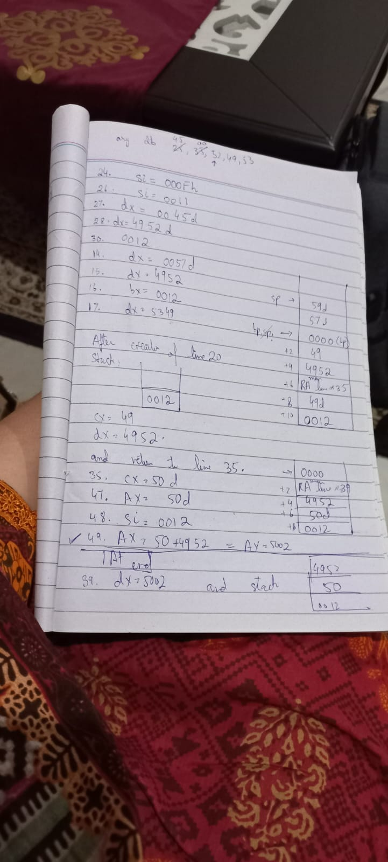

Question 3 [5 Marks]
Write the following code on provided answer sheet and clearly illustrate which jumps will be taken or not taken in front of each line of code. Also, update the flag registers value after execution of the code.
mov al, 50
cmp al, -30
ja L1 ;NOT TAKEN
L2: jnl L3 ;TAKEN
L1: jg L2 ;NOT TAKEN
L3: jnge L4 ;NOT TAKEN
L4: jbe LM ;TAKEN
LM: mov bl, -15

;FLAGS
CF: 1 ZF: 0 SF: 0
OF: 0 PF: 1 AF: 0

Question 4 [10 Marks]
Use Booth’s Multiplication Algorithm to multiply 8 (take it as Q) by -28 (take it as M). Show all steps considering your computer’s data width equal to 6-bits.

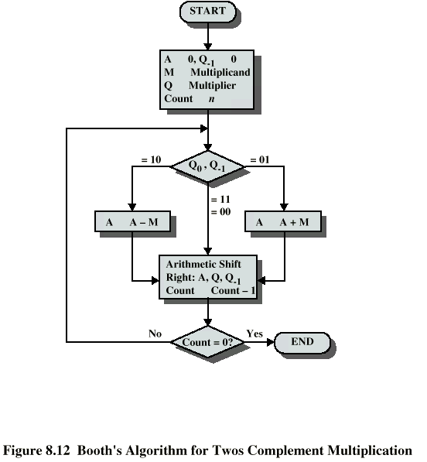

Operation | A | Q | Q₋₁ | M
n=6 | 000000 | 001000 | 0 | 100100
SAR=5 | 000000 | 000100 | 0 | 100100
SAR=4 | 000000 | 000010 | 0 | 100100
SAR=3 | 000000 | 000001 | 0 | 100100
A=A-M  SAR=2 | 011100  001110 | 000001  000000 | 0  1 | 100100  100100
A=A-M  SAR=1 | 110010  111001 | 000000  000000 | 1  0 | 100100  100100
SAR=0 | 111100 | 100000 | 0 | 100100

Answer = 111100100000
2’s complement = 000011100000
Decimal = -28x8 = -224

